**Name: Session:**

**Programming II**

**Lab Exercise 3/4/2025**

1. Create an application that displays the following form:

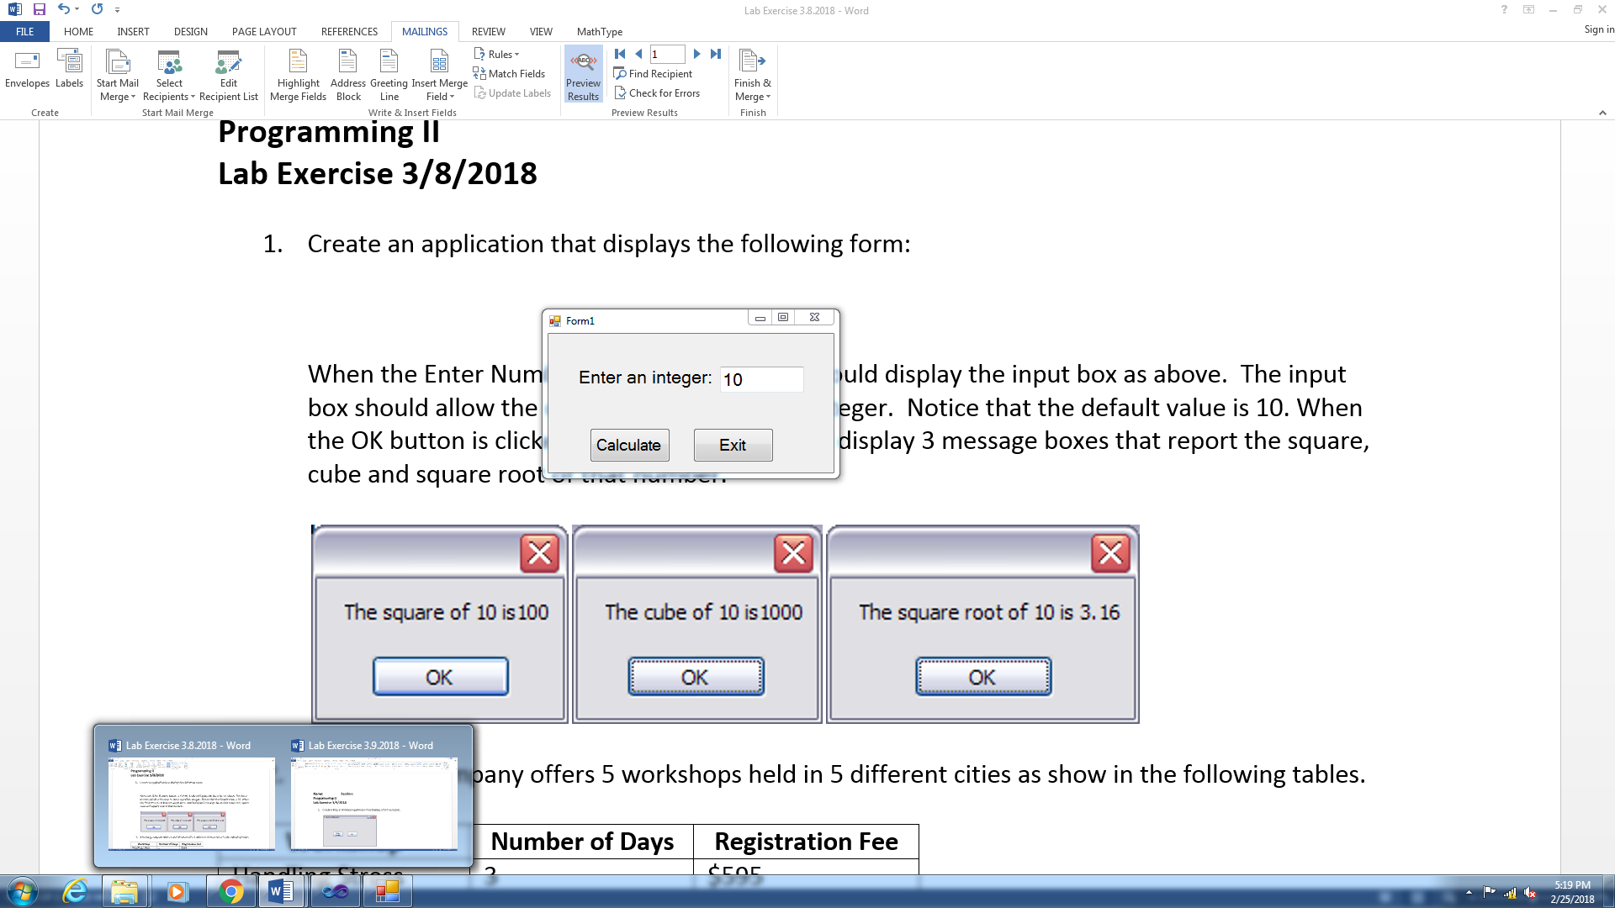

When the Calculate button is clicked, the application should display 3 message boxes that report the square, cube and square root of that number.

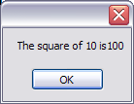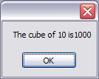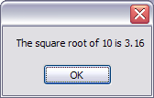

1. A training company offers 5 workshops held in 5 different cities as show in the following tables.

|  |  |  |
| --- | --- | --- |
| **Workshop** | **Number of Days** | **Registration Fee** |
| Handling Stress | 3 | $595 |
| Time Management | 3 | $695 |
| Supervision Skills | 3 | $995 |
| Negotiation | 5 | $1295 |
| How to Interview | 1 | $395 |

|  |  |
| --- | --- |
| **Location** | **Lodging Fee per Day** |
| Austin | $95 |
| Chicago | $125 |
| Dallas | $110 |
| Orlando | $100 |
| Phoenix | $92 |
| Raleigh | $90 |

When the customer registers for a workshop, he or she must pay the registration and lodging fees for the selected location. For example here are the charges to attend the Supervision Skills workshop in Orlando.

Registration: $995

Lodging: $100 x 3 days = $300 total

Total: $1,295

The application should allow the user to select a workshop from one list box and a location in another list box. When the user clicks on the Add Workshop button, the application should add the total cost of the workshop (registration fee + lodging) to the third list box. When the user clicks the Calculate Total button, the total costs of all workshops should be displayed in the label. The Reset button should deselect the workshop and location from the first two list boxes, clear the third list box, and clear the total cost label.

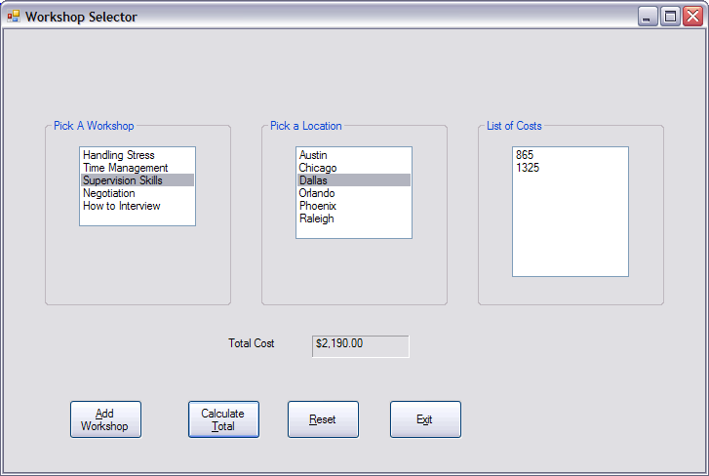

1. Create a Sum of Numbers application that displays a form as below.

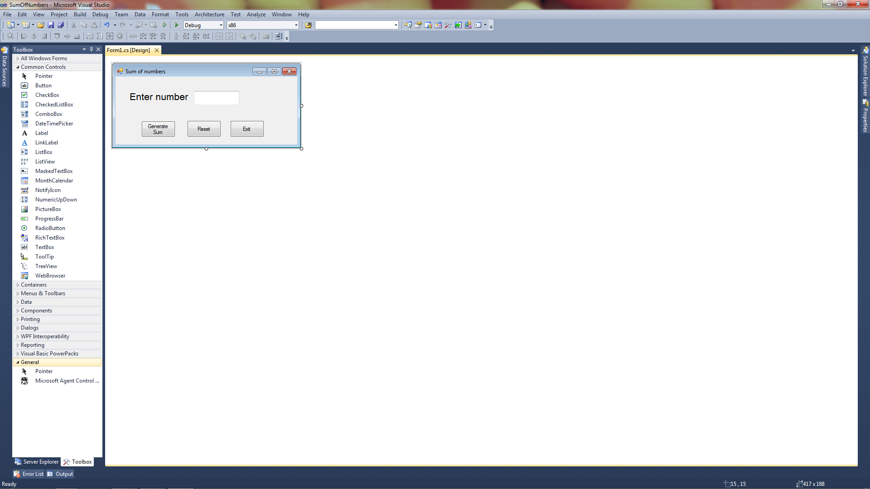

When the Generate Sum button is clicked the application should display a MessageBox with the sum of the integers from 1 to the integer entered.

1. If you know a vehicle’s speed and the amount of time it has traveled, you can calculate the distance it has traveled as follows:

distance = rate * time

Create an application similar to the form below.

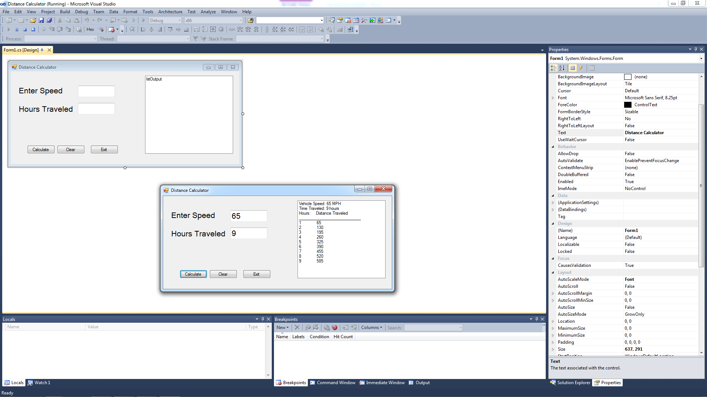

When the user clicks the Calculate button, the application uses a loop to display in a list box the vehicle speed, time traveled, and the distance traveled at the end of each hour.

**When you have completed problem 1 - 4, submit a screen shot of your application as well as your source code.**